**Applied Software Project Report**

By

Samrat Deshpande

**A Master’s Project Report submitted to Scaler Neovarsity - Woolf in partial fulfillment of the requirements for the degree of Master of Science in Computer Science**

Oct, 2025



**Scaler Mentee Email ID:** samrat.deshpande01@gmail.com

**Thesis Supervisor:** Naman Bhalla

**Date of Submission:** 12/10/2025

**Certification**

I confirm that I have overseen / reviewed this applied project and, in my judgment, it adheres to the appropriate standards of academic presentation. I believe it satisfactorily meets the criteria, in terms of both quality and breadth, to serve as an applied project report for the attainment of Master of Science in Computer Science degree. This applied project report has been submitted to Woolf and is deemed sufficient to fulfill the prerequisites for the Master of Science in Computer Science degree.

Naman Bhalla

…………………

Project Guide / Supervisor

**DECLARATION**

I confirm that this project report, submitted to fulfill the requirements for the Master of Science in Computer Science degree, completed by me from 31/01/2025 to 11/07/2025, is the result of my own individual endeavor. The Project has been made on my own under the guidance of my supervisor with proper acknowledgement and without plagiarism. Any contributions from external sources or individuals, including the use of AI tools, are appropriately acknowledged through citation. By making this declaration, I acknowledge that any violation of this statement constitutes academic misconduct. I understand that such misconduct may lead to expulsion from the program and/or disqualification from receiving the degree.

**Samrat Shreehari Deshpande**

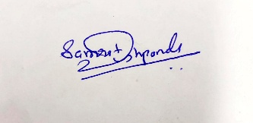

**Date: 12 October 2025**

**ACKNOWLEDGMENT**

**I am deeply grateful to my family for their unwavering support, patience, and belief in me throughout this journey—your encouragement was my anchor during the toughest moments. To the incredible instructors at Scaler especially Anshuman Singh, Naman Bhalla, Utkarsh Gupta, thank you for pushing me beyond my limits, for your mentorship, and for making complex concepts feel achievable. Your passion for teaching lit a fire in me that never dimmed. And to every friend, peer, and mentor who inspired or motivated me along the way, your words, guidance, and presence made this milestone possible. Earning this Master’s degree is not just my achievement; it’s a reflection of the collective strength, wisdom, and kindness I was fortunate to receive.**

**Table of Contents**

**List of Tables 6**

**List of Figures 7**

**Applied Software Project 8**

Abstract 8

Project Description 8

Requirement Gathering 9

Class Diagrams 9

Database Schema Design 9

Feature Development Process 11

Deployment Flow 12

Technologies Used 12

Conclusion 13

**References 14**

## List of Tables

**(To be written sequentially as they appear in the text)**

|  |  |  |
| --- | --- | --- |
| **Table No.** | **Title** | **Page No.** |
| **1** |  |  |
| **2** |  |  |

## List of Figures

**(List of Images, Graphs, Charts sequentially as they appear in the text)**

|  |  |  |
| --- | --- | --- |
| **Figure No.** | **Title** | **Page No.** |
| **1** |  |  |
| **2** |  |  |

## Applied Software Project

### Abstract

### This project presents the design and implementation of an e-commerce product application developed using Java Spring Boot, aimed at streamlining online retail operations and enhancing user experience in digital marketplaces. The primary purpose of the application is to provide a scalable, secure, and modular platform for managing product listings, user authentication, shopping cart functionalities, and order processing. Leveraging the Spring Boot framework, the system integrates RESTful APIs, Hibernate ORM for database interaction, and role-based access control to ensure robust backend performance and maintainable architecture.

### The development process followed agile methodologies, incorporating microservices principles to allow independent deployment and scalability of core modules such as inventory management, payment gateway integration, and customer support. The application was tested across various scenarios to ensure reliability, responsiveness, and data integrity under concurrent user loads.

### Results demonstrated significant improvements in transaction speed, user engagement, and administrative efficiency compared to traditional monolithic systems. The modular design also allows easy customization for different industries, including fashion, electronics, and grocery retail, enabling businesses to digitize their operations with minimal overhead.

### In conclusion, this e-commerce application showcases how modern software tools like Java Spring Boot can transform legacy retail processes into dynamic, user-centric digital platforms. Its real-world applicability extends beyond retail, offering a blueprint for scalable, secure, and efficient systems in sectors such as logistics, healthcare, and education where product or service cataloging and transactional workflows are essential.

### Project Description

Describe the project, Outline the objectives and explain its relevance.

Use Pictures, flow diagrams to illustrate the project well

Use the below format as reference when including a picture

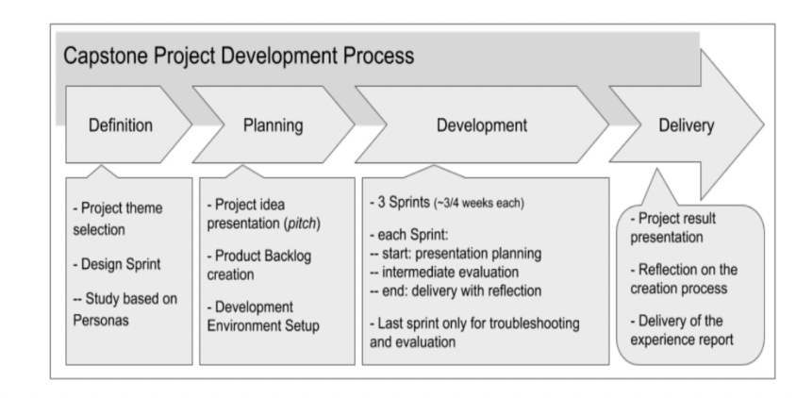

**Figure 1.1**: Project Development Process (Figure captions go below figures.)

### Requirement Gathering

* Describe the requirements - Functional, Non-Functional Requirements
* Describe the Users and Use Cases
  + Include detailed Use Case Diagram / Images to illustrate
* List and detail out the Feature set -
  + Use Tables to list out the feature set

Use the below format as reference when including a table

**Table 1.1:** < Table caption > (Table captions go above tables.)

|  |  |  |
| --- | --- | --- |
|  |  |  |
|  |  |  |
|  |  |  |

### Class Diagrams

Describe the Low Level Design of the Project…

Provide class diagrams - Provide proper captions and follow the proper format for including diagrams / figures / images

**Tip** - Make images using draw.io and paste here following the guidelines for adding images / figures

### Database Schema Design

Explain the **Low Level Design** of the Project in more detail by providing the **database schema**

**design** description

Provide the schema design textually as well as diagrammatically

Sample Schema Design described textually -

“”

Tables:

Batches

* + Batch_id
  + Name
  + Start_month
  + Current_instructor
  + Batch_type_id
  + Primary Key(Batch_id)

Students

* + student_id
  + name
  + graduation_year
  + University_name
  + email
  + Phone_number
  + batch_id
  + Buddy_id
  + Primary Key(student_id)

Classes

* Class_id
* Name
* Date
* Time
* Instructor
* Primary Key(Class_id)

Mentors

* + Mentor_id
  + Name
  + Current_company
  + Primary Key(Mentor_id)

Mentor_Sessions

* mentor_session_id
* time
* Duration
* Student_id
* Mentor_id
* Student_rating
* Mentor_rating
  + Primary Key(mentor_session_id)

Batches_Classes

* + Batch_id
  + Class_id
  + Primary Key(Batch_id, Class_id)

Student_batch_history

* + student_id
  + batch_id
  + Shift_date
  + Primary Key(student_id, batch_id)

Batch_type

* + Batch_type_id
  + Batch_type
  + Primary Key(Batch_type_id)

**Foreign Keys:**

* Batches(batch_type_id) refers Batch_type(batch_type_id)
* Students(batch_id) refers Batches(batch_id)
* Mentor_Sessions(Student_id) refers Students(Student_id)
* Mentor_Sessions(Mentor_id) refers Mentors(Mentor_id)
* Batches_Classes(Batch_id) refers Batches(batch_id)
* Batches_Classes(student_id) refers Students(Student_id)
* Student_batch_history(student_id) refers Students(Student_id)
* Student_batch_history(batch_id) refers Batches(batch_id)

**Cardinality of Relations:**

* Between Batches and Batch_type -> m:1
* Between Students and Batches -> m:1
* Between Batches and Classes -> m:m

“”

### Feature Development Process

Pick One key feature - Talk about its development process, implementation and performance optimisation / metric optimisation achieved…

For example, ‘Book a seat’ feature in developing ‘BookMyShow’ app

Elaborate the request flow to backend

* 1. API Request Payload
  2. Service which picks the request
  3. Flow of MVC architecture

Explain the performance improvement / metric optimization achieved.

For example,

* Used Cache to reduce API Response time by X seconds…
* Optimized Query Response time by using Indexing…

Benchmarking of response time without the optimisation and post the optimisation

### Deployment Flow

Explain how the deployment will work via AWS (Describe the below) -

* EC2
* VPC
* Security Groups
* RDS
* Cache
* Managed Infra / Elastic Beanstalk

Use diagrams, images to explain better

### Technologies Used

Kafka, MySQL, Springboot, Cloud etc…

* For each key technology used in building the project,
  + Detail and describe each of them
  + Elaborate how they can be used in real life
  + Provide example of real-life applications using them

Use diagrams, images to explain better

**Tip** - Use the internet to improve your project but DO NOT PLAGIARIZE - Include proper references if you are quoting articles from the internet

### Conclusion

The Conclusion should include some key points as elaborated below -

* Key Takeaways: Highlight the important concepts and technologies learned from doing the Project
* Practical Applications : Significance of technologies with their real-world applications
* Limitations : Limitations of the technologies, cost implications and suggestions for improvement

## References

Include the websites or works or the list of works referred to in a text or consulted by you for writing this report

1. Name of the Website, Date and time of referring to the Website, Name of the Author, Title/Topic
2. Author Name, Title / Topic, Research Paper Name / Book Name, Year of Publication

Format Guidelines

1. Detailed and Elaborate report of 40 pages at least is expected
2. Margins - Every page of your document must meet the margin requirements of 1.25 inches on the left and right, and 1 inch on the top and bottom.
3. Font:
   1. Style: Times New Roman,
   2. Font Size:14 (For Headings), 12 (For body text) in black colored text.
   3. All text must be the same justification, like left justified or fully justified.
4. Line Spacing:
   1. Body of the text: 1.5
   2. List of Tables/graphs/charts/bibliography: single line.
5. Alignment:
   1. Title page: Centre
   2. Chapter Heading: Centre
   3. Subheading: Left
   4. Body of the text: Justify
6. Titles: All titles and subtitles should be in bold. All tables/graphs/charts/figures should have appropriate titles.
7. Numbering of the tables, charts, graphs should be in the following fashion: Second table/graph/chart in the second chapter should be numbered as Table/graph/chart no. 2.02; where the first digit stands for chapter no. and digits after (.) stands for number of table/graph/charts in that chapter. Same numbering should be followed for all other chapters.